Azure Functions
- Serverless coding platform (Functions as a Service, FaaS)
- Designed for nano-service architectures and event-based applications
- Scales up and down very quickly
- Highly scalable
- Supports popular languages and frameworks (.NET & .NET Core, Java, Node.js, Python, PowerShell, etc.)
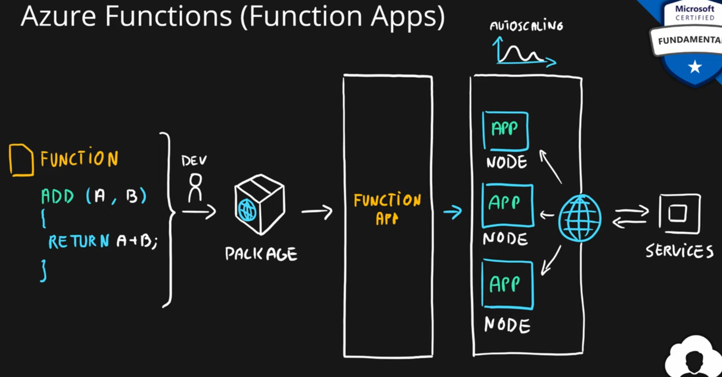

Azure Logic Apps
- Serverless enterprise integration service (PaaS)
- 200+ connectors for popular services
- Designed for orchestration of
  - business processes,
  - integration workflows for applications, data, systems and services
- No-code solution
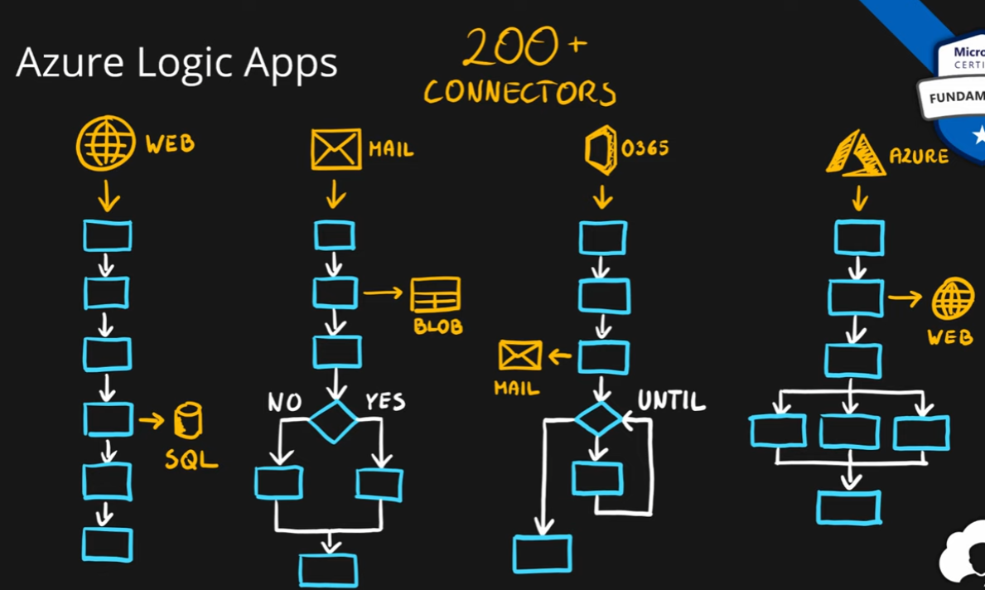

Azure Event Grid
- Fully managed serverless event routing service
- Uses publish-subscribe model
- Designed for event-based and near-real time applications
- Supports dozen of built-in events from most common Azure services
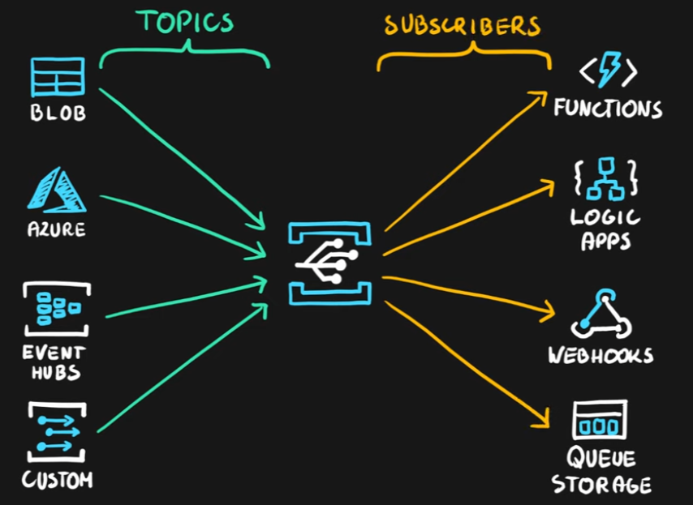

Summary
